Sheet 4

Computing algorithms
Q1:
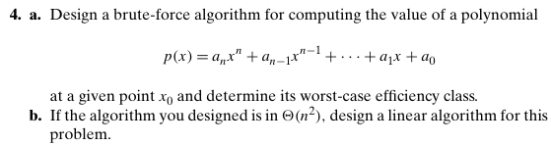
Q2: Sort the list E,X,A,M,P,L,E in alphabetical order by selection sort and bubble sort
Q3: State if the selection sort and bubble sort are stable and in-place.
Q4:
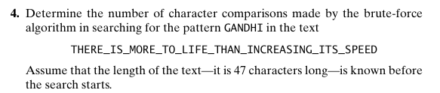

N=47 , M=6
Alignments= 47-6+1= 42 possible alg.
Total comparsion 41 +2= 43
Q5:
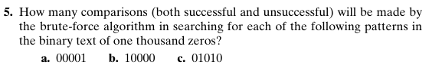
N = 1000
M=5
Total alig =1000-5+1=996 possible algs
Comparssion 5 , 4 succ , 1 fail
Total comparison =996*5=4980

b.10000
Total comparison =996*1=996

C.01010
Total =996*2=1992

